# STUDENTS ADAPTABILITY LEVEL IN ONLINE EDUCATION

AN INDUSTRY ORIENTED MINI REPORT

Submitted to

**JAWAHARLAL NEHRU TECNOLOGICAL UNIVERSITY, HYDERABAD**

In partial fulfillment of the requirements for the award of the degree of

**BACHELOR OF TECHNOLOGY**

**In**

**COMPUTER SCIENCE AND ENGINEERING(Data Science)**

Submitted By

**ABHINAYA BANDARI 21UK1A6747**

**RAMYAPEDDI21UK1A6721**

**PRIYANKA AGULLA21UK1A6742**

**SHIVA PRASAD PUTTA 21UK1A6757**

Under the guidance of

**MS. K. NAVYA**

Assistant Professor



## DEPARTMENT OF COMPUTER SCIENCE AND ENGINEERING(DATASCIENCE) VAAGDEVI ENGINEERING COLLEGE

Affiliated to JNTUH, HYDERABAD

BOLLIKUNTA, WARANGAL (T.S) – 506005

**DEPARTMENT OF**

**COMPUTER SCIENCE AND ENGINEERING(DATA SCIENCE)**

## VAAGDEVI ENGINEERING COLLEGE(WARANGAL)



**CERTIFICATE OF COMPLETION**

**INDUSTRY ORIENTED MINI PROJECT**

This is to certify that the UG Project Phase-1 entitled “STUDENT ADAPTABILITY LEVEL IN ONLLINE EDUCATION” is being submitted by ABHINAYA BANDARI(21UK1A6747),RAMYA PEDDI(21UK1A6721),PRIYANKA AGULLA(21UK1A6742),SHIVA PRASAD PUTTA(21UK1A6757) in partial fulfillment of the requirements for the award of the degree of Bachelor of Technology in Computer Science & Engineering(Data science) to Jawaharlal Nehru Technological University Hyderabad during the academic year 2023- 2024.

**Project Guide HOD**

**Ms.K.Navya Dr. K. Sharmila**

(Assistant Professor) (Professor)

**External**

# ACKNOWLEDGEMENT

We wish to take this opportunity to express our sincere gratitude and deep sense of respect to our beloved **Dr.P.PRASAD RAO,** Principal, Vaagdevi Engineering College for making us available all the required assistance and for his support and inspiration to carry out this UG Project Phase-1 in the institute.

We extend our heartfelt thanks to **Dr.K.SHARMILA**, Head of the Department of CSE, Vaagdevi Engineering College for providing us necessary infrastructure and thereby giving us freedom to carry out the UG Project Phase-1.

We express heartfelt thanks to Smart Bridge Educational Services Private Limited, for their constant supervision as well as for providing necessary information regarding the UG Project Phase-1 and for their support in completing the UG Project Phase-1.

We express heartfelt thanks to the guide, **K.NAVYA,** Assistant professor, Department of CSE for his constant support and giving necessary guidance for completion of this UG Project Phase-1.

Finally, we express our sincere thanks and gratitude to my family members, friends for their encouragement and outpouring their knowledge and experience throughout the thesis.

**ABHINAYABANDARI (21UK1A6747) RAMYAPEDDI(21UK1A6721) PRIYANKA AGULLA(21UK1A6742) SHIVAPRASAD PUTTA (21UK1A6757)**

# ABSTRACT

Adaptability among students in online education has become a crucial focus in recent times. This abstract explores various dimensions of student adaptability in the context of online learning environments, including factors influencing adaptability, strategies for fostering adaptability, and outcomes associated with adaptable behavior. The study draws on theoretical frameworks and empirical research to provide insights into how educators and institutions can support and enhance student adaptability, ultimately contributing to more effective online educational experiences.

# TABLE OF CONTENTS:-

1. **INTRODUCTION ...................................................................... 5** 
   1. **OVERVIEW… ......................................................................... 5**
   2. **PURPOSE ................................................................................. 5**
2. **LITERATURE SURVEY .......................................................... 8** 
   1. **EXISTING PROBLEM ........................................................... 8**
   2. **PROPOSED SOLUTION ..................................................... 8-9**
3. **THEORITICAL ANALYSIS… .............................................. 10** 
   1. **BLOCK DIAGRAM ............................................................... 10**
   2. **HARDWARE /SOFTWARE DESIGNING ................... 10-11**
4. **EXPERIMENTAL INVESTIGATIONS ........................... 12-13**
5. **FLOWCHART… ...................................................................... 14**
6. **RESULTS… ......................................................................... 15-18**
7. **ADVANTAGES AND DISADVANTAGES… ....................... 19**
8. **APPLICATIONS ...................................................................... 20**
9. **CONCLUSION ......................................................................... 20**
10. **FUTURE SCOPE… .............................................................. 21**
11. **BIBILOGRAPHY ............................................................. 22-23**
12. **APPENDIX (SOURCE CODE)&CODE SNIPPETS .... 24-30**

## 1.INTRODUCTION

**1.1.OVERVIEW**

In the realm of online education, assessing student adaptability levels is critical for understanding their ability to thrive in digital learning environments. Adaptability encompasses a range of skills and behaviors that enable students to effectively navigate and succeed in online courses. Key factors influencing student adaptability include technological proficiency, time management skills, self-discipline, and the ability to cope with changes and challenges inherent in online learning.

Research indicates that students with higher adaptability levels tend to demonstrate better academic performance, higher satisfaction with online courses, and improved overall learning outcomes. Educators and institutions play a vital role in fostering student adaptability by providing comprehensive support, including training in digital tools, promoting self-regulated learning strategies, offering flexible learning opportunities, and creating a supportive online community.

Understanding and enhancing student adaptability in online education not only improves individual student experiences but also contributes to the overall effectiveness and success of online learning programs. Ongoing research and tailored interventions are essential to continuously improve strategies for enhancing student adaptability and ensuring equitable access and success in online education.

**1.2.PURPOSE**

**Informing the The purpose of studying student adaptability levels in online education is multifaceted:**

**1. Understanding Factors:** To identify and understand the key factors that influence how students adapt to online learning environments. This includes technological proficiency, self-regulation skills, time management, resilience, and other socio-emotional factors.

**2. Improving Support Systems:** To develop effective strategies and support systems that can help students enhance their adaptability skills. This could involve interventions related to curriculum design, instructional methods, technological support, and student services.

**3. Enhancing Learning Outcomes:** To promote better academic performance, satisfaction, and retention rates among students by fostering adaptability. When students can adapt effectively to online learning challenges, they are more likely to achieve their educational goals and succeed in their courses.

**4. Informing Policy and Practice:** To provide evidence-based recommendations for educators, institutions, and policymakers on how to create conducive environments for online learning that support student adaptability. This includes understanding equity issues and ensuring all students have equal opportunities to succeed in online education.

**5. Contributing to Research:** To contribute to the academic literature and ongoing research in the field of online education and adaptability. By studying adaptability levels, researchers can deepen their understanding of student behaviors and responses in digital learning contexts.

Ultimately, the purpose of studying student adaptability in online education is to optimize learning experiences, promote student engagement, and facilitate academic success in an increasingly digital educational landscape.

## 2.LITERATURE SURVEY

**2.1EXISTING PROBLEM**

* The If online education were not available in this generation, several significant problems could arise:

1. **Limited Access to Education:** Many students, especially in remote or underserved areas, would face challenges accessing quality education. Online education provides an opportunity for those who cannot attend traditional schools due to geographical, financial, or health-related reasons.

2. **Educational Disruptions:** Events like pandemics, natural disasters, or other emergencies could disrupt traditional in-person education, leading to prolonged periods without learning. Online education helps maintain continuity during such disruptions.

3. **Reduced Flexibility:** Online education offers flexibility for non-traditional students, such as working adults or parents, who need to balance their studies with other responsibilities. Without online options, these individuals might find it difficult to pursue further education.

4. **Limited Educational Resources:** Online education provides access to a wide range of resources, including courses, lectures, and research materials that might not be available locally. This lack of access could limit the quality and breadth of education.

5. **Inequality in Education:** Online education can help bridge the gap between different socioeconomic groups by providing more equitable access to learning opportunities. Without it, the disparity in education quality between wealthy and poor regions could widen.

6. **Missed Opportunities for Lifelong Learning:** Online education supports lifelong learning and continuous professional development. Without it, individuals might have fewer opportunities to upskill or reskill, impacting their career growth and adaptability in a rapidly changing job market.

7. **Reduced Global Collaboration:** Online education enables students and educators from around the world to collaborate and share knowledge. Without it, there would be fewer opportunities for international partnerships and exchange of ideas.

8**. Increased Pressure on Physical Infrastructure:** Traditional educational institutions would face increased pressure to accommodate all students in physical classrooms, leading to overcrowded facilities and strained resources.

* In summary, the absence of online education would likely exacerbate educational inequalities, limit access to learning opportunities, and hinder the adaptability and resilience of the education system in the face of various challenges.

**PROPOSED SOLLUTION**

1**. Flexibility and Convenience**: Students can access courses and materials at any time and from any location, allowing them to balance education with work, family, and other responsibilities.

2. **Accessibility:** Online education can reach students in remote or underserved areas where traditional educational institutions may not be available.

3. **Variety of Courses and Programs:** There is a wide range of online courses and degree programs available, covering diverse subjects and allowing students to pursue specific interests or career paths.

4. **Cost-Effective:** Online education often costs less than traditional in-person education due to savings on commuting, housing, and sometimes lower tuition fees.

5. **Personalized Learning:** Students can learn at their own pace, revisiting materials as needed and advancing more quickly through concepts they understand well.

6. **Access to Expertise:** Online platforms can connect students with instructors and experts from around the world, offering a broader range of perspectives and knowledge.

7. **Technological Skills:** Engaging with online education platforms helps students develop essential digital skills that are valuable in the modern workforce.

**3.1. BLOCK DIAGRAM**

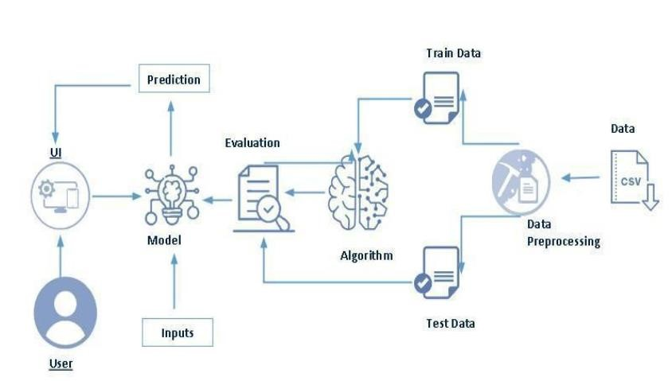

**3.2. SOFTWARE DESIGNING**

The following is the Software required to complete this project:

* **Google Colab**: Google Colab will serve as the development and execution environment for your predictive modeling, data preprocessing, and model training tasks. It provides a cloud-based Jupyter Notebook environment with access to Python libraries and hardware acceleration.
* **Dataset (CSV File)**: The dataset in CSV format is essential for training and testing your predictive model. It should include historical air quality data, weather information, pollutant levels, and other relevant features.
* **Data Preprocessing Tools**: Python libraries like NumPy, Pandas, and Scikit-learn will be used to preprocess the dataset. This includes handling missing data, feature scaling, and data cleaning.
* **Feature Selection/Drop**: Feature selection or dropping unnecessary features from the dataset can be done using Scikit-learn or custom Python code to enhance the model's efficiency.
* **Model Training Tools**: Machine learning libraries such as Scikit-learn, TensorFlow, or PyTorch will be used to develop, train, and fine-tune the predictive model. Regression or classification models can be considered, depending on the nature of the AQI prediction task.
* **Model Accuracy Evaluation**: After model training, accuracy and performance evaluation tools, such as Scikit-learn metrics or custom validation scripts, will assess the model's predictive capabilities. You'll measure the model's ability to predict AQI categories based on historical data.
* **UI Based on Flask Environment**: Flask, a Python web framework, will be used to develop the user interface (UI) for the system. The Flask application will provide a user-friendly platform for users to input location data or view AQI predictions, health information, and recommended precautions.
* Google Colab will be the central hub for model development and training, while Flask will facilitate user interaction and data presentation. The dataset, along with data preprocessing, will ensure the quality of the training data, and feature selection will optimize the model. Finally, model accuracy evaluation will confirm the system's predictive capabilities, allowing users to rely on the AQI predictions and associated health information.

## 4.EXPERIMENTAL INVESTIGATION

In this project, we have used Student Adaptability Level in Online Education. This dataset is a csv file consisting of labelled data and having the following columns-

1. **Gender**: Male, Female, other
2. **Age**: Age in years
3. **Education**: High school, Undergraduate, Graduate etc.
4. **IT Student**: Yes/No
5. **Location**: Urban, Suburban,Rural.
6. **Load-Shedding**: Frequency and duration of power outages.
7. **Financial Condition**: Household income level income level (Low, Middle, High)
8. **Internet Type**: Dial-up, Broadband, Fiber, Mobile Data,etc.
9. **Network Type**: WiFi, Mobile Network(4G/5G),Ethernet,etc.
10. **Class Duration**: Length of online classes(in minutes or hours)
11. **Self Lms**: Time spent on self-study outside class hour.
12. **Device**: Desktop, Laptop, Tablet, Smartphone, etc.
13. **Adaptivity Level**: Measured through surveys or performance metrics (e.g., grades, engagement level, adaptability scales).

For the dataset we selected, it consists of more than the columns we want to predict it . So, we have chosen the feature drop it contains the columns that we are going to predict the value.

## 6.RESULT

**HOME PAGE**

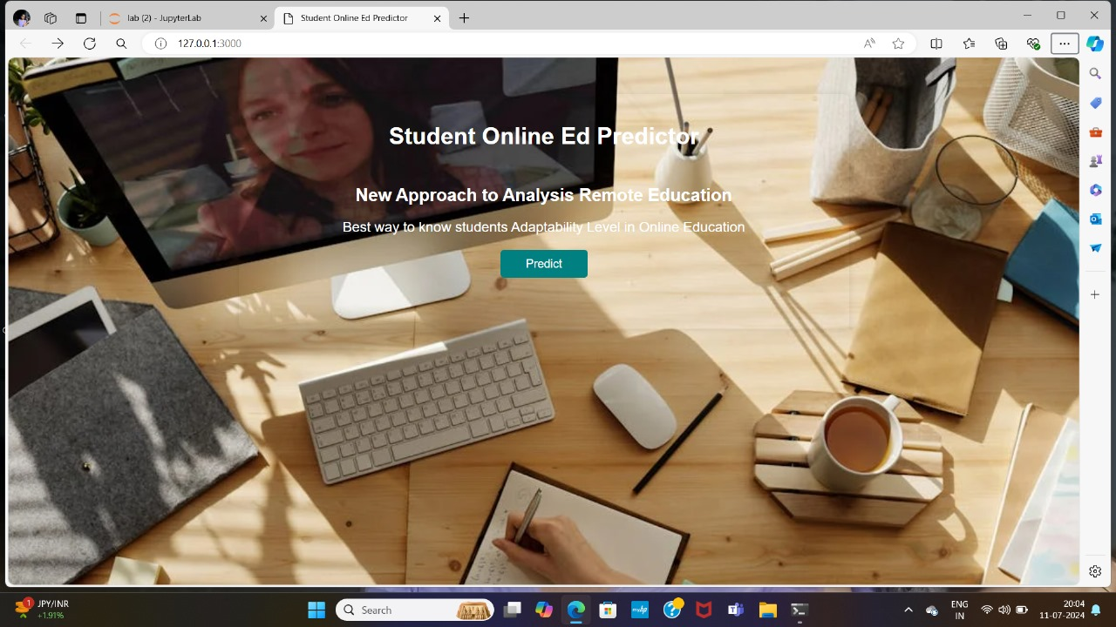

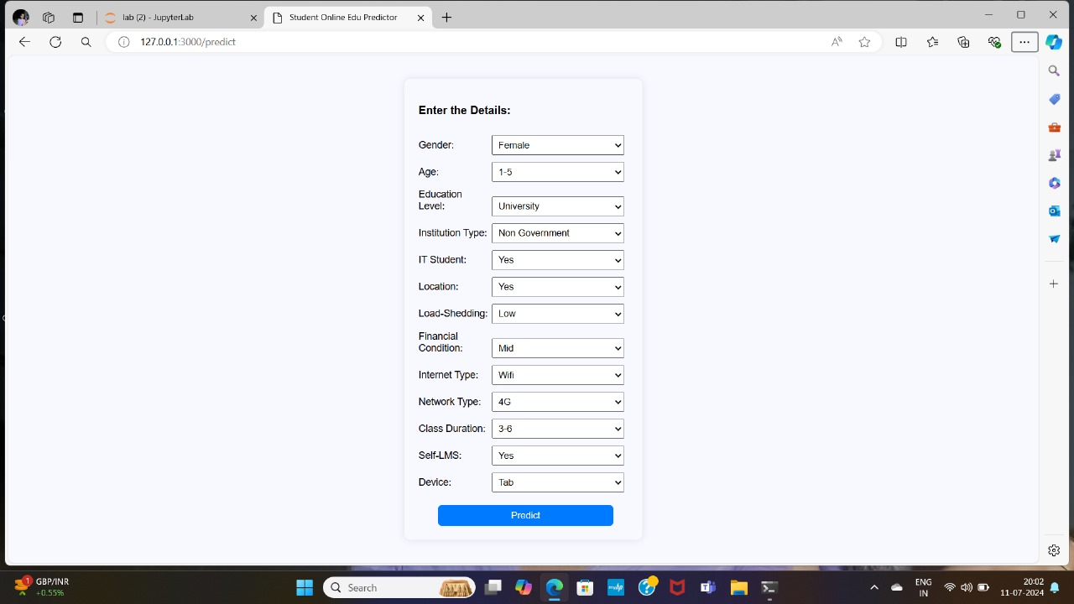

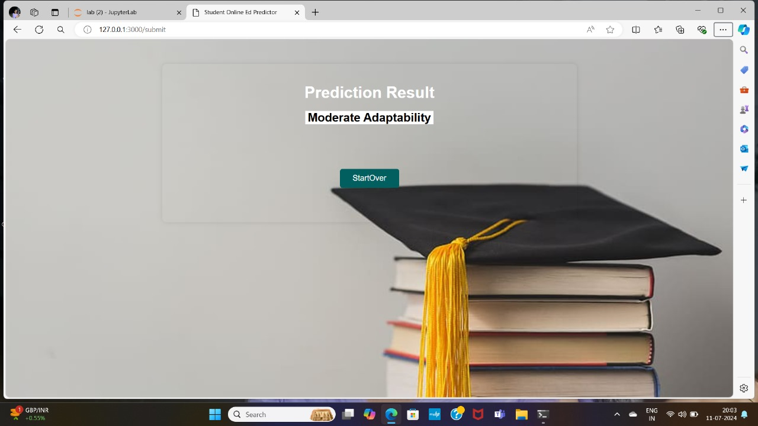

## 7.ADVANTAGES AND DISADVANTAGES

**ADVANTAGES:**

1. **Flexibility:**

- Students can learn at their own pace.

- Allows for personalized learning experiences.

- Accommodates different learning styles and preferences.

1. **Convenience:**

- Access to resources from anywhere.

- No time or location constraints.

- Enables balancing education with other commitments.

1. **Interactive Learning:**

- Utilizes multimedia tools for engaging content.

- Encourages active participation.

- Enhances understanding through interactive exercises and simulations.

1. **Customized Learning:**

- Tailored learning experiences to individual needs.

- Ability to revisit and review materials as needed.

- Opportunities for self-directed learning and exploration.

1. Overall, student adaptability in online education offers a range of benefits that cater to diverse learning needs and preferences.

**DISADVANTAGES:**

1. **Lack of Social Interaction:** Online education often lacks the social aspects of traditional classroom settings, making it difficult for students to develop interpersonal skills and build relationships with peers and instructors.
2. **Technical Issues:** Not all students have access to reliable internet connections or adequate technological devices, leading to disruptions in their learning process.
3. **Self-Discipline and Motivation:** Online education requires a high level of self-discipline and motivation. Students who struggle with these aspects may find it challenging to keep up with coursework and stay engaged.
4. **Limited Access to Resources:** Certain educational resources, such as labs, libraries, and hands-on experiences, may be less accessible or entirely unavailable in an online format.
5. **Teacher-Student Interaction**: The lack of face-to-face interaction can hinder immediate feedback and personalized support, potentially impacting the quality of learning.

## 8.APPLICATIONS

1. **Adaptability Assessments:** Implementing assessments or surveys at the beginning of online courses to gauge students' familiarity with online learning tools, self-motivation, and time management skills.
2. **Tailored Learning Paths:** Using adaptability assessments to customize learning paths for students based on their strengths and weaknesses in online learning environments.
3. **Personalized Support**: Providing personalized support and guidance to students based on their adaptability levels, offering additional resources or mentoring where needed.
4. **Skill Development Programs:** Offering skill development programs or workshops to enhance students' adaptability in areas such as digital literacy, self-regulated learning, and resilience in online settings.
5. **Feedback and Reflection:** Encouraging regular feedback from students on their online learning experiences and using this input to refine course designs and support strategies.
6. **Peer Support Networks:** Facilitating peer support networks or online communities where students can share tips, experiences, and strategies for adapting to online learning.

## 9.CONCLUSION

* In conclusion, assessing and fostering students' adaptability in online education is crucial for enhancing their learning experiences and outcomes. By understanding and addressing the challenges associated with online learning environments, institutions can effectively support students in developing essential skills such as digital literacy, self-regulation, and resilience. Implementing personalized support, skill development programs, and continuous feedback mechanisms can further empower students to navigate and thrive in online education settings. Ultimately, prioritizing adaptability equips students with the tools needed to succeed academically and professionally in an increasingly digital world.

## 10.FUTURE SCOPE

The future scope of student adaptability in online education is promising, with several trends and advancements likely to enhance how students adjust and thrive in digital learning environments. Here are some potential future developments:

•**AI and Machine Learning**: These technologies can create personalized learning experiences by analyzing student data and adapting content to meet individual needs.

• **Adaptive Learning Systems**: Platforms that adjust the difficulty and type of content based on student performance can help learners at all levels stay engaged and challenged appropriately.

• **Virtual and Augmented Reality**: Immersive technologies can create interactive and engaging learning experiences, making it easier for students to grasp complex concepts.

* **Gamification**: Incorporating game-like elements can increase motivation and engagement, making learning more enjoyable and effective.
* **Universal Design for Learning (UDL)**: Future online education platforms may increasingly adopt UDL principles to cater to diverse learning needs and styles.
* **Mobile Learning**: As mobile technology continues to evolve, students will have more opportunities to learn on-the-go, enhancing adaptability.
* **AI Tutors and Chatbots**: These can provide immediate assistance and support to students, helping them overcome challenges quickly.
* **Mental Health and Wellbeing Support**: Online education platforms may integrate more resources and support for student mental health, acknowledging the importance of wellbeing in academic success.
* **Advanced Collaboration Platforms**: Future tools may offer more seamless and effective ways for students to collaborate, share ideas, and work on projects together, mimicking or even enhancing in-person interactions.
* **Global Classrooms**: The ability to connect with peers from around the world can broaden perspectives and enhance adaptability by exposing students to diverse viewpoints and learning styles.

## 11.BIBILOGRAPHY

1. Anderson Here is a bibliography for sources related to the future scope of student adaptability in online education:
2. Ally, M. (2004). Foundations of Educational Theory for Online Learning. In T. Anderson & F. Elloumi (Eds.), Theory and Practice of Online Learning (pp. 3-31). Athabasca University.
3. - This book provides foundational theories for understanding how online learning can be effectively designed and implemented.
4. Bates, T. (2019). Teaching in a Digital Age: Guidelines for Designing Teaching and Learning. BCcampus.
5. - Bates discusses various strategies for teaching in a digital age, including personalized learning and the use of technology to enhance student engagement and adaptability.
6. Boettcher, J. V., & Conrad, R. M. (2016). The Online Teaching Survival Guide: Simple and Practical Pedagogical Tips. Jossey-Bass.
7. - This guide offers practical tips for educators on how to create engaging and effective online learning environments that support student adaptability.
8. Clark, R. C., & Mayer, R. E. (2016). E-Learning and the Science of Instruction: Proven Guidelines for Consumers and Designers of Multimedia Learning. Wiley.
9. - This book explores the science behind effective e-learning design, including strategies for enhancing student adaptability through multimedia learning.
10. Hodges, C., Moore, S., Lockee, B., Trust, T., & Bond, A. (2020). The Difference Between Emergency Remote Teaching and Online Learning. Educause Review
11. - This article differentiates between emergency remote teaching and well-planned online learning, highlighting the importance of design in student adaptability.
12. Means, B., Toyama, Y., Murphy, R., Bakia, M., & Jones, K. (2010). Evaluation of Evidence-Based Practices in Online Learning: A Meta-Analysis and Review of Online Learning Studies. U.S. Department of Education.
13. - This meta-analysis reviews evidence-based practices in online learning, providing insights into what works best for enhancing student adaptability.
14. Picciano, A. G. (2017). Theories and Frameworks for Online Education: Seeking an Integrated Model*. Online Learning, 21(3), 166-190.
15. - Picciano discusses various theories and frameworks for online education and their implications for student adaptability.
16. Siemens, G., Gasevic, D., & Dawson, S. (Eds.). (2015). Preparing for the Digital University: A Review of the History and Current State of Distance, Blended, and Online Learning. Athabasca University.
17. - This comprehensive review covers the evolution of online learning and future directions, including the role of adaptive learning technologies.
18. Traxler, J. (2018). Learning with Mobiles in Developing Countries: Technology, Language, and Literacy. In C. Dede, J. Richards, & B. Saxberg (Eds.), Learning Engineering for Online Education* (pp. 203-221). Routledge.
19. - Traxler explores the impact of mobile technology on learning in developing countries and its implications for student adaptability.
20. Veletsianos, G. (Ed.). (2020). *Learning Online: The Student Experience. Johns Hopkins University Press.
21. - This edited volume provides insights into the student experience in online learning environments, highlighting challenges and strategies for enhancing adaptability.
22. These sources provide a comprehensive view of the current research and future trends in online education, emphasizing the importance of adaptability and the various factors that influence it.

## 12.APPENDIX

**Model building :**

1)Dataset

2)Google colab and VS code Application Building

1.HTML file (Index file, Predict file )

1. CSS file
2. Models in pickle format

**SOURCE CODE:**

**INDEX.HTML**

    <!DOCTYPE html>

<html lang="en">

<head>

    <meta charset="UTF-8">

    <meta name="viewport" content="width=device-width, initial-scale=1.0">

    <title>Student Online Ed Predictor</title>

    <style>

        body {

             background-image: url("https://images.pexels.com/photos/4144923/pexels-photo-4144923.jpeg?auto=compress&cs=tinysrgb&w=1260&h=750&dpr=1");

            background-size: cover;

            font-family: Arial, sans-serif;

            margin: 0;

            padding: 0;

        }

        .container {

            /*background-image: url("https://images.pexels.com/photos/4126724/pexels-photo-4126724.jpeg?auto=compress&cs=tinysrgb&w=1260&h=750&dpr=1");*/

            max-width: 800px;

            margin: 50px auto;

            padding: 20px;

            box-shadow: 0 0 10px rgba(0, 0, 0, 0.1);

            border-radius: 8px;

        }

        .header {

            /*background-image: url("https://images.pexels.com/photos/4126724/pexels-photo-4126724.jpeg?auto=compress&cs=tinysrgb&w=1260&h=750&dpr=1");*/

            color: white;

            text-align: center;

            padding: 20px;

            border-radius: 8px 8px 0 0;

        }

        .header h1 {

            margin: 0;

            font-size: 2em;

        }

        .content {

            text-align: center;

            padding: 30px;

           /* background-color: #00a0b0;*/

            color: white;

            border-radius: 0 0 8px 8px;

        }

        .content h2 {

            margin: 0;

            font-size: 1.5em;

        }

        .content p {

            font-size: 1.2em;

        }

        .button {

            display: block;

            width: 100px;

            margin: 20px auto;

            padding: 10px;

            background-color: #008080;

            color: #ffffff;

            text-align: center;

            border-radius: 5px;

            text-decoration: none;

        }

        .button:hover {

            background-color: #005f5f;

        }

    </style>

</head>

<body>

    <div class="container">

        <div class="header">

            <h1>Student Online Ed Predictor</h1>

        </div>

        <div class="content">

            <h2>New Approach to Analysis Remote Education</h2>

            <p>Best way to know students Adaptability Level in Online Education</p>

            <a href="{{ url_for('predict') }}" class="button">Predict</a>

        </div>

    </div>

</body>

</html>

**PREDICT.HTML**

<!DOCTYPE html>

<html lang="en">

<head>

    <meta charset="UTF-8">

    <meta name="viewport" content="width=device-width, initial-scale=1.0">

    <title>Student Online Edu Predictor</title>

    <style>

        /* General styles */

        body {

            font-family: Arial, sans-serif;

            background-color: #f8f8ff;

            margin: 0;

            padding: 0;

            display: flex;

            justify-content: center;

            align-items: center;

            height: 100vh;

        }

        .container {

            background-color:  #f8f8ff;

            padding: 20px;

            border-radius: 8px;

            box-shadow: 0 0 10px rgba(0, 0, 0, 0.1);

            width: 300px; /* Decreased form width */

        }

        h1 {

            text-align: center;

        }

        .form {

            display: flex;

            flex-direction: column;

        }

        .opt_lab {

            margin-top: 10px;

            display: inline-block;

            width: 100px; /* Adjusted label width */

            font-size: 14px;

        }

        .select {

            width: calc(100% - 110px); /* Adjusted select width */

            padding: 5px;

            margin-top: 10px;

        }

        button {

            margin-top: 18px;

            padding: 7px;

            background-color: #007bff;

            color: white;

            border: none;

            border-radius: 5px;

            cursor: pointer;

            width:250px;

            margin-left: 28px;

        }

        button:hover {

            background-color: #0056b3;

        }

    </style>

</head>

<body>

        <div class="form">

            <form class="form" action="{{url_for('submit')}}" method="POST">

                <div class="container">

                    <p><b>Enter the Details:</b></p>

                    <label class="opt_lab" for="fname1">Gender:</label>

                    <select class="select" id="fname1" name="fname1">

                        <option value="1">Female</option>

                        <option value="0">Male</option>

                    </select>

                    <br>

                    <label class="opt_lab" for="fname2">Age:</label>

                    <select class="select" id="fname2" name="fname2">

                        <option value="0">1-5</option>

                        <option value="1">11-15</option>

                        <option value="2">16-20</option>

                        <option value="3">21-25</option>

                        <option value="4">26-30</option>

                        <option value="5">6-10</option>

                    </select>

                    <br>

                    <label class="opt_lab" for="fname3">Education Level:</label>

                    <select class="select" id="fname3" name="fname3">

                        <option value="2">University</option>

                        <option value="0">College</option>

                        <option value="1">School</option>

                    </select>

                    <br>

                    <label class="opt_lab" for="fname4">Institution Type:</label>

                    <select class="select" id="fname4" name="fname4">

                        <option value="1">Non Government</option>

                        <option value="0">Government</option>

                    </select>

                    <br>

                    <label class="opt_lab" for="fname5">IT Student:</label>

                    <select class="select" id="fname5" name="fname5">

                        <option value="1">Yes</option>

                        <option value="0">No</option>

                    </select>

                    <br>

                    <label class="opt_lab" for="fname6">Location:</label>

                    <select class="select" id="fname6" name="fname6">

                        <option value="1">Yes</option>

                        <option value="0">No</option>

                    </select>

                    <br>

                    <label class="opt_lab" for="fname7">Load-Shedding:</label>

                    <select class="select" id="fname7" name="fname7">

                        <option value="1">Low</option>

                        <option value="0">High</option>

                    </select>

                    <br>

                    <label class="opt_lab" for="fname8">Financial Condition:</label>

                    <select class="select" id="fname8" name="fname8">

                        <option value="0">Mid</option>

                        <option value="1">Poor</option>

                        <option value="2">Rich</option>

                    </select>

                    <br>

                    <label class="opt_lab" for="fname9">Internet Type:</label>

                    <select class="select" id="fname9" name="fname9">

                        <option value="1">Wifi</option>

                        <option value="0">Mobile Data</option>

                    </select>

                    <br>

                    <label class="opt_lab" for="fname10">Network Type:</label>

                    <select class="select" id="fname10" name="fname10">

                        <option value="2">4G</option>

                        <option value="1">3G</option>

                        <option value="0">2G</option>

                    </select>

                    <br>

                    <label class="opt_lab" for="fname11">Class Duration:</label>

                    <select class="select" id="fname11" name="fname11">

                        <option value="2">3-6</option>

                        <option value="1">1-3</option>

                        <option value="0">0</option>

                    </select>

                    <br>

                    <label class="opt_lab" for="fname12">Self-LMS:</label>

                    <select class="select" id="fname12" name="fname12">

                        <option value="1">Yes</option>

                        <option value="0">No</option>

                    </select>

                    <br>

                    <label class="opt_lab" for="fname13">Device:</label>

                    <select class="select" id="fname13" name="fname13">

                        <option value="2">Tab</option>

                        <option value="1">Mobile</option>

                        <option value="0">Computer</option>

                    </select>

                    <br>

                    <button type="submit">Predict</button>

                </div>

            </form>

        </div>

</body>

</html>

**APP.PY**

from flask import Flask,render_template,request

#model

import pickle

with open('model_pkl' , 'rb') as f:

    model = pickle.load(f)

app = Flask(__name__)

@app.route('/')

def index():

    return render_template('intro.html')

@app.route('/result')

def result():

    return render_template('result.html')

@app.route('/predict')

def predict():

    return render_template('predict.html')

@app.route('/submit',methods=['POST'])

def submit():

    if request.method == 'POST':

        f1 =  float(request.form.get('fname1'))

        f2 =  float(request.form.get('fname2'))

        f3 =  float(request.form.get('fname3'))

        f4 =  float(request.form.get('fname4'))

        f5 =  float(request.form.get('fname5'))

        f6 =  float(request.form.get('fname6'))

        f7 =  float(request.form.get('fname7'))

        f8 =  float(request.form.get('fname8'))

        f9 =  float(request.form.get('fname9'))

        f10 = float(request.form.get('fname10'))

        f11 = float(request.form.get('fname11'))

        f12 = float(request.form.get('fname12'))

        f13 = float(request.form.get('fname13'))

        result=model.predict([[f1,f2,f3,f4,f5,f6,f7,f8,f9,f10,f11,f12,f13]])

    res=''

    if int(result[0])==0:

        res='High Adaptability'

    elif int(result[0])==1:

        res= 'Low Adaptability'

    else:

        res = 'Moderate Adaptability'''

    return render_template('result.html',result=res)

if __name__ == '__main__':

    app.run(debug=True,port=3000)

## CODE SNIPPETS

### MODEL BUILDING

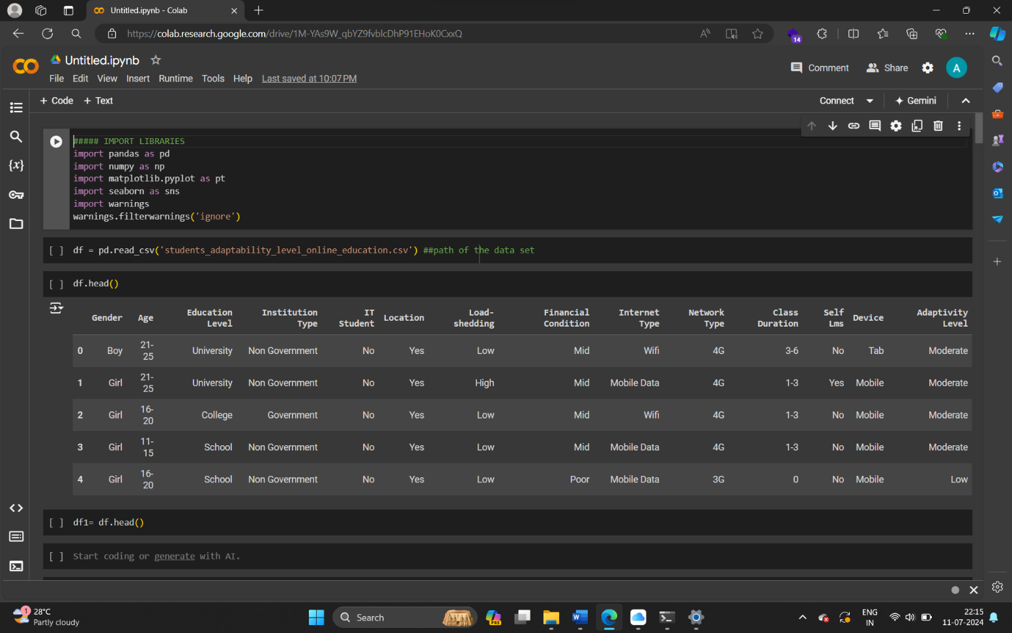

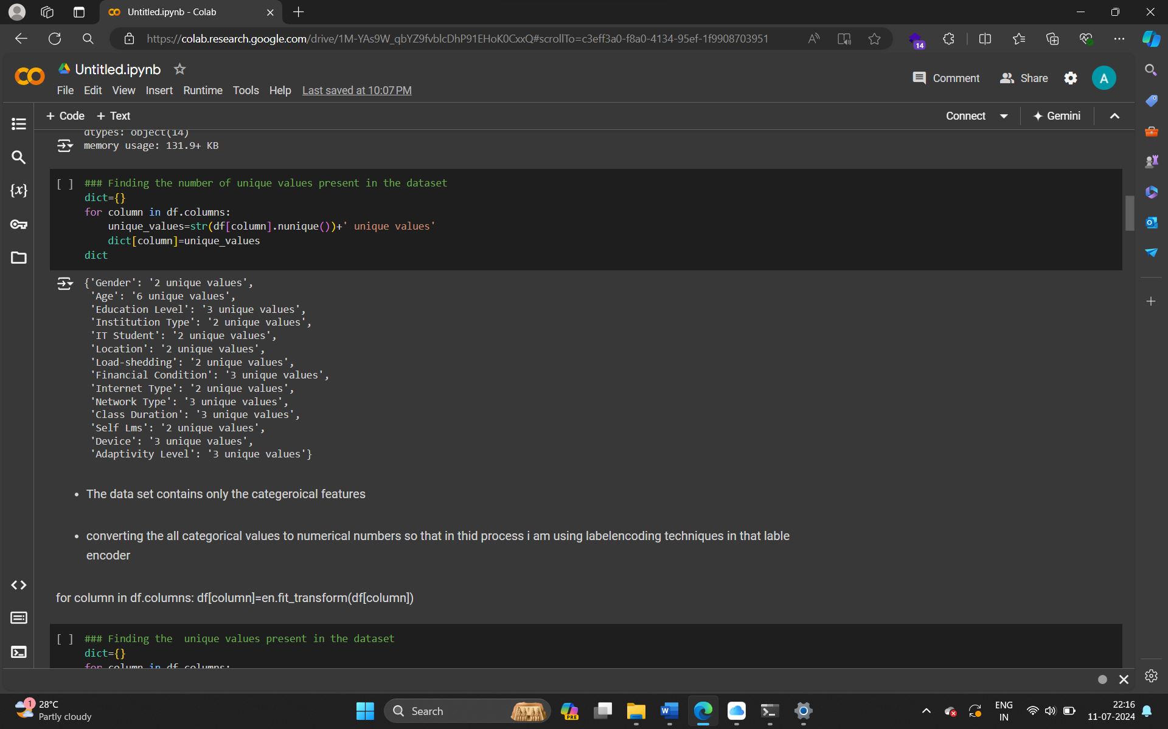

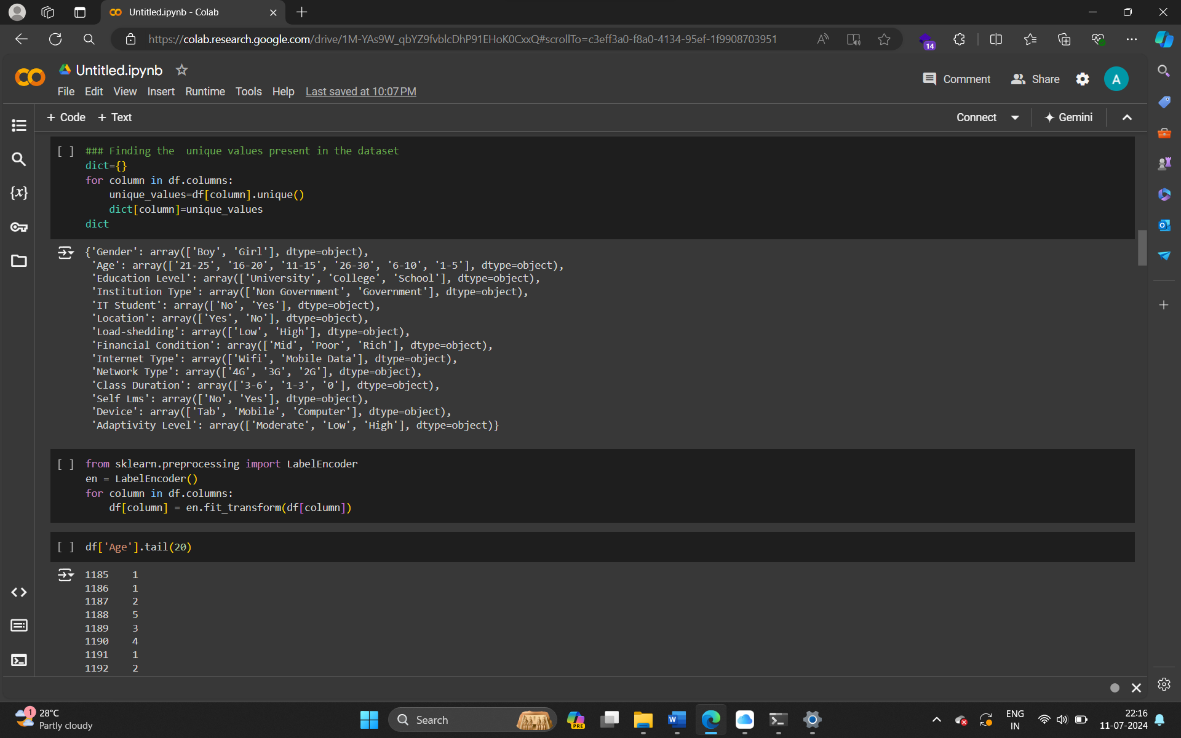



### COUNT PLOT

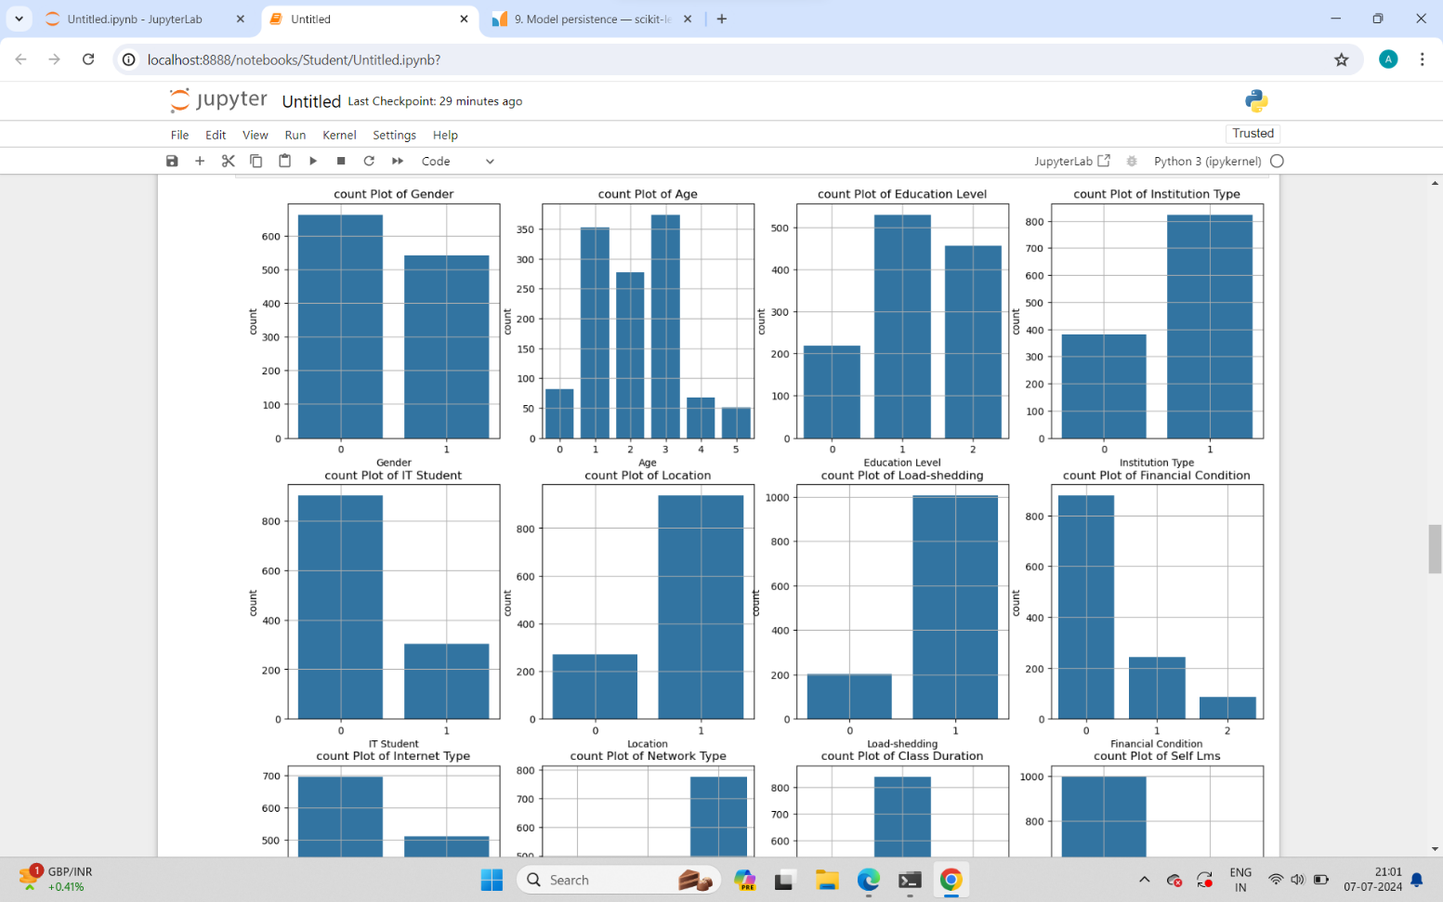

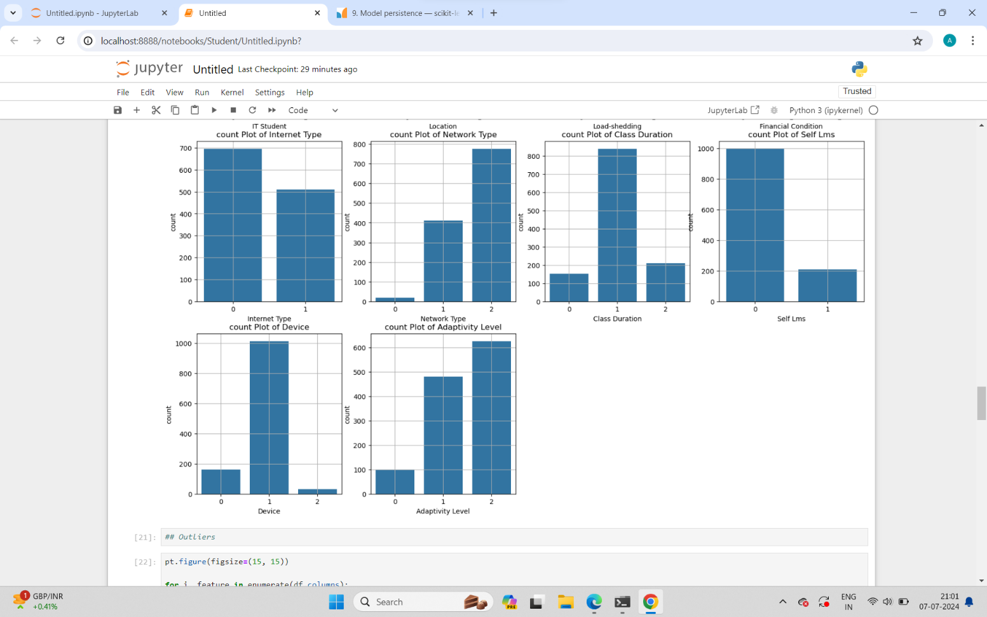

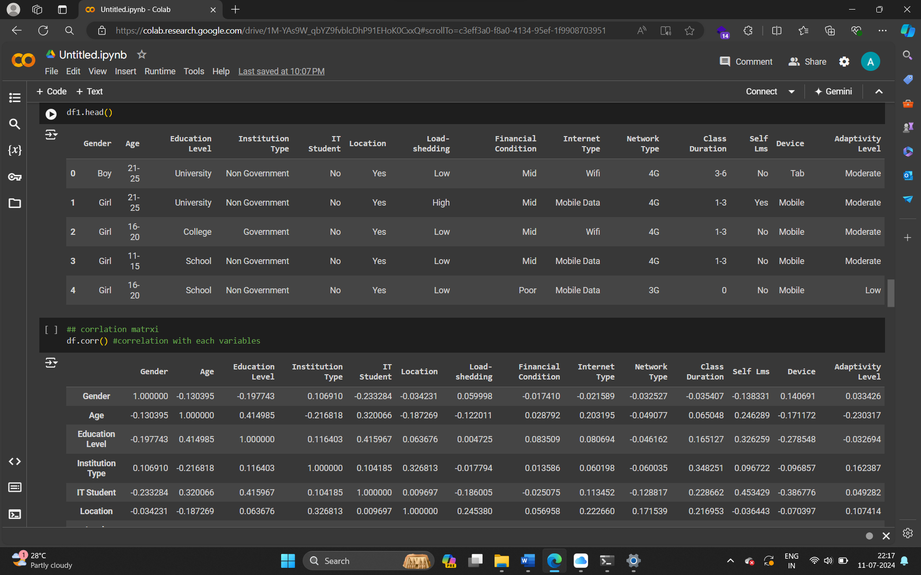

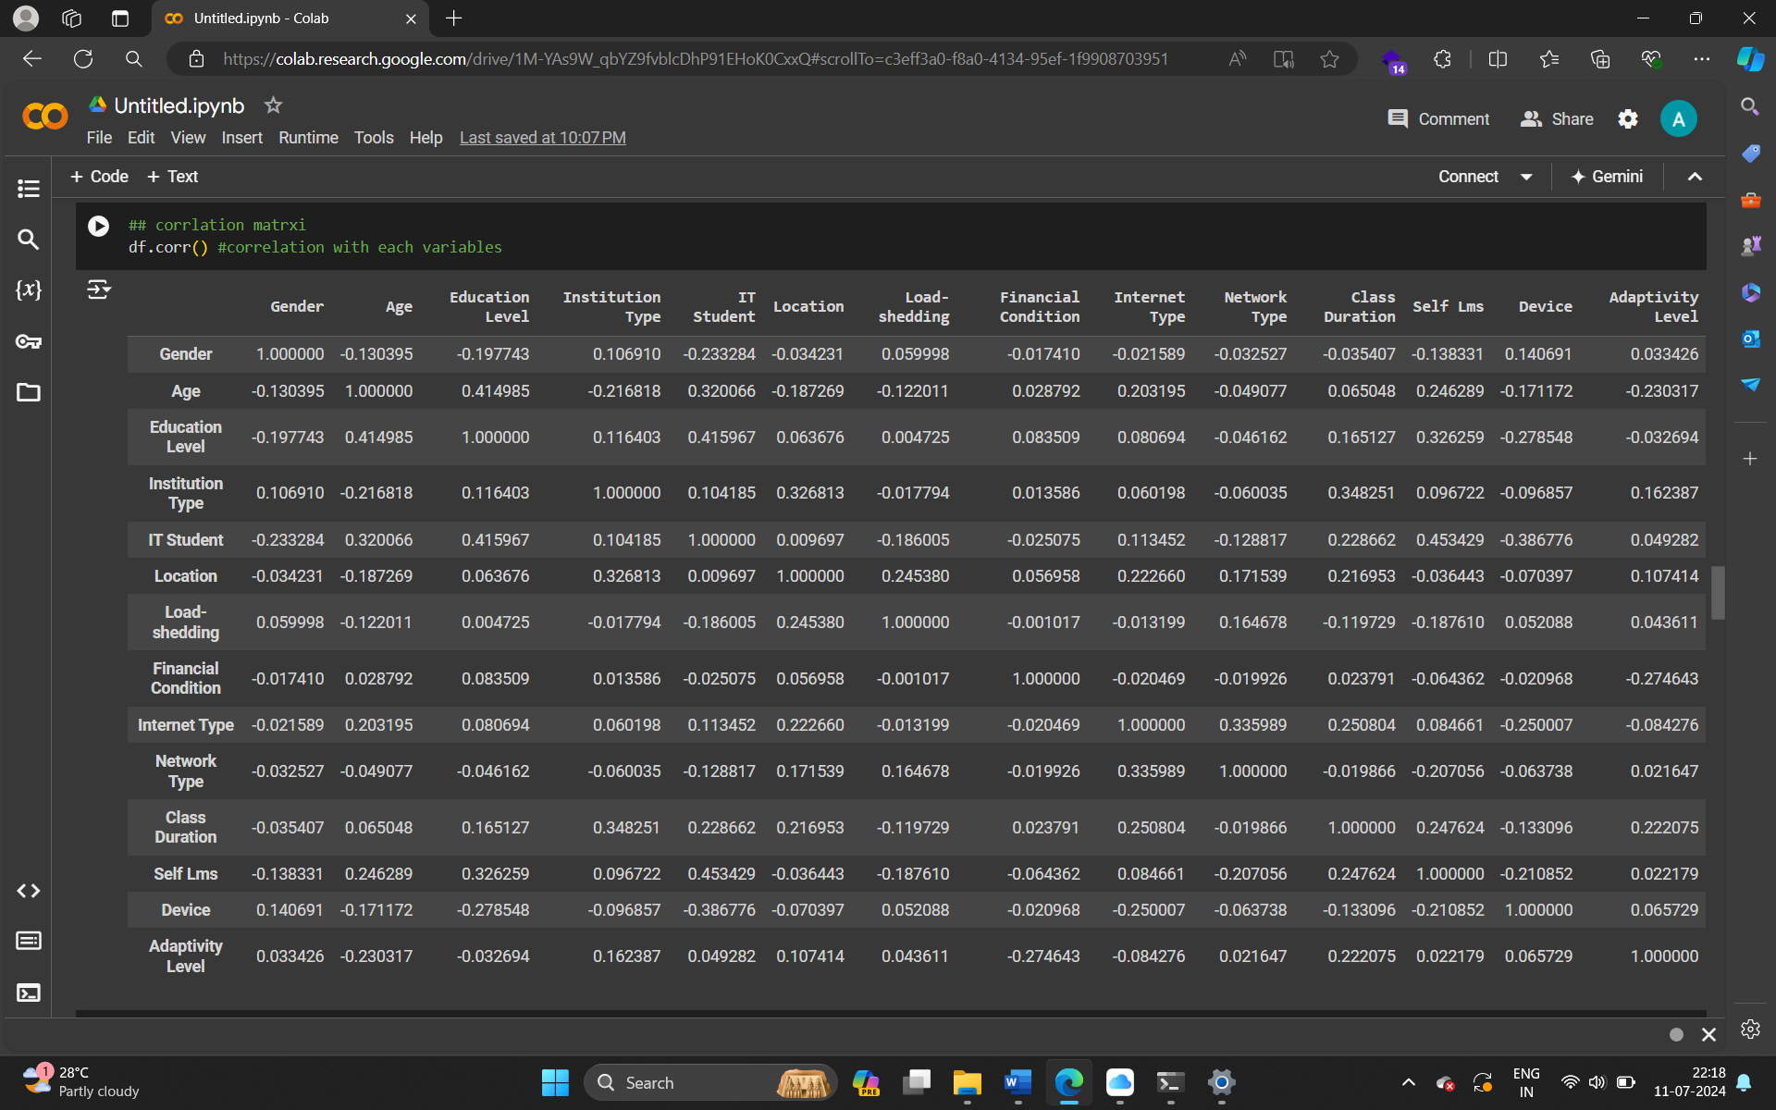

### DESCRIPTIVE ANALYSIS

